

Power Bi interview Question

Power Bi Interview Questions

1. https://youtu.be/Cozc9WNBRt4?si=IGd8Ri2RFyZePNJt

1 Cross Filtering Vs Cross Highlighting - <https://www.youtube.com/watch?v=-fwjqEWbr1c>

Cross Highlighting – when you select one value in a visual in Power Bi report then the data in the other visual gets highlighted this is called as cross highlighting. It just highlight out the data and it deems the unrelated data

Cross Highlighting – when you select one value in visual and the data in other visual gets filtered out

Meaning only the related data can be seen and the unrelated data gets filtered out is called Cross Filtering.

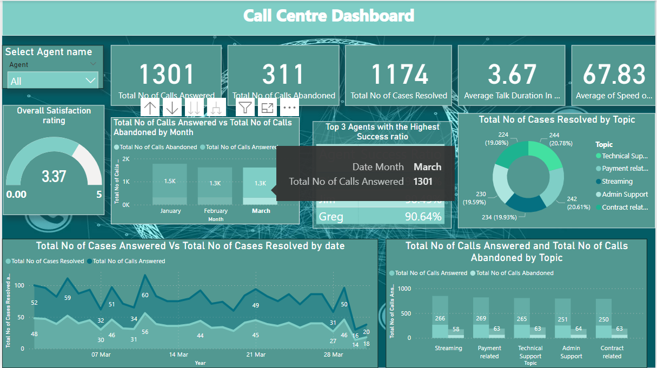

So for the Selected month March , For the Donut Chart I have done Cross Filtering (Just showing data of march Month ) whereas for the bar chart below RHS I have done Cross Highlighting so it just Highlights the March related Data and filters out unrelated data.

The default setting for all visual is Cross Highlighting but that can be changed to Cross Filtering by just one click by going to Settings Tab.

Cross Report –

Based on the value selected from one visual in a report , it will drillthrough that value in OTHER REPORT.

Till now we had heard that based on a value selected from a visual in one page it will drill through that value to the other pages as well of the SAME REPORT.

But in cross report based on the value selected, it filters out the OTHER REPORT itself.

* For Cross-Report, that setting should be enabled in Source as well as Target report

`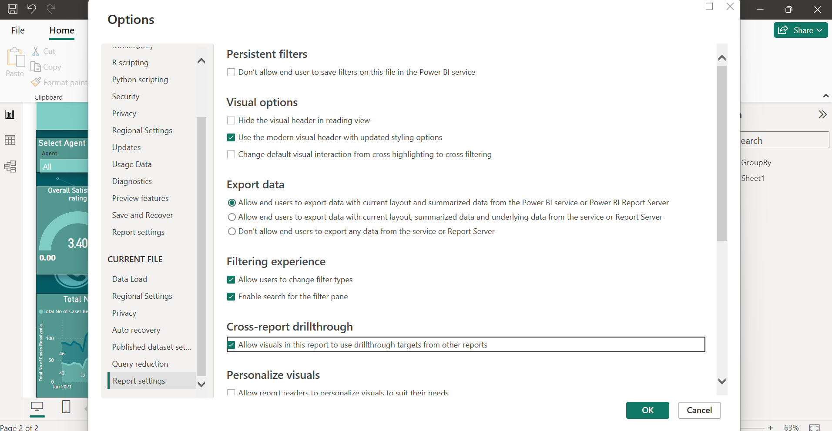

Enable this “Cross-Report Drillthrough” Setting in Source as well as Target report.

**Power Bi Report Vs Paginated Report**

A major advantage of paginated reports is their ability to print all the data in a table, no matter how long. Picture that you place a table in a Power BI report. You see some of its rows in the table on the page, and you have a scroll bar to see the rest. If you print that page, or export it to PDF, the only rows that print are the ones you saw on the page.

Now say you place the same table in a paginated report. When you print it or export it to PDF, the paginated report has as many pages as necessary to print every row in that table.

**(**So the major difference between Power Bi report and Paginated Report lies in Table Visual –

i.e if we Export a Power Bi Report to PDF (Export to PDF basically takes the snapshot of that page) then in the table visual only the records that are available or displayed on the screen without scrolling the table visual will be exported to PDF

whereas in Paginated Report If we export it to PDF all records of the table visual (whether there are 10 pages or 20 pages or more than that) are exported to PDF.

Paginated Report can be created on Power BI Service by clicky on My Workspace -->New -->Paginated Report --> Select dataset --> OK

But the UI of Creating Paginated Report on pbi Service is not so good.  
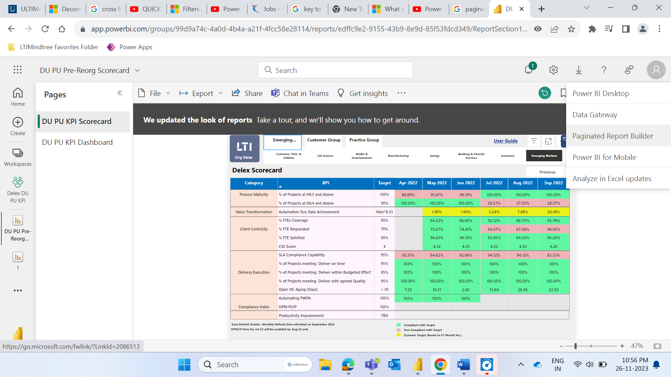

So instead Click on the Download icon in PBI Service in top RHS and Click on Paginated Report Builder which is like the desktop version to create paginated Report.

**Difference between Power Query and Power Pivot**

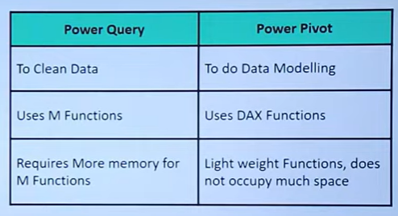

**Difference between Calculated Column and Measure**

